Use VSCode +PlatformIO to compile Marlin2.0

1.Download the Marlin2.0 firmware : https://github.com/MarlinFirmware/Marlin/archive/2.0.x.zip

When the download is complete, unzip it and note the location of the unzipped files.

1. Download & Install VSCode from <https://code.visualstudio.com/Download> .

After the download is completed, double-click the installation. After the installation, open VSCode.

3.You also need to install the PlatformIO plugin

A:Click on the “Extensions” icon enter PlatformIO in step 2 and click step 3 Install to install.

Please wait.

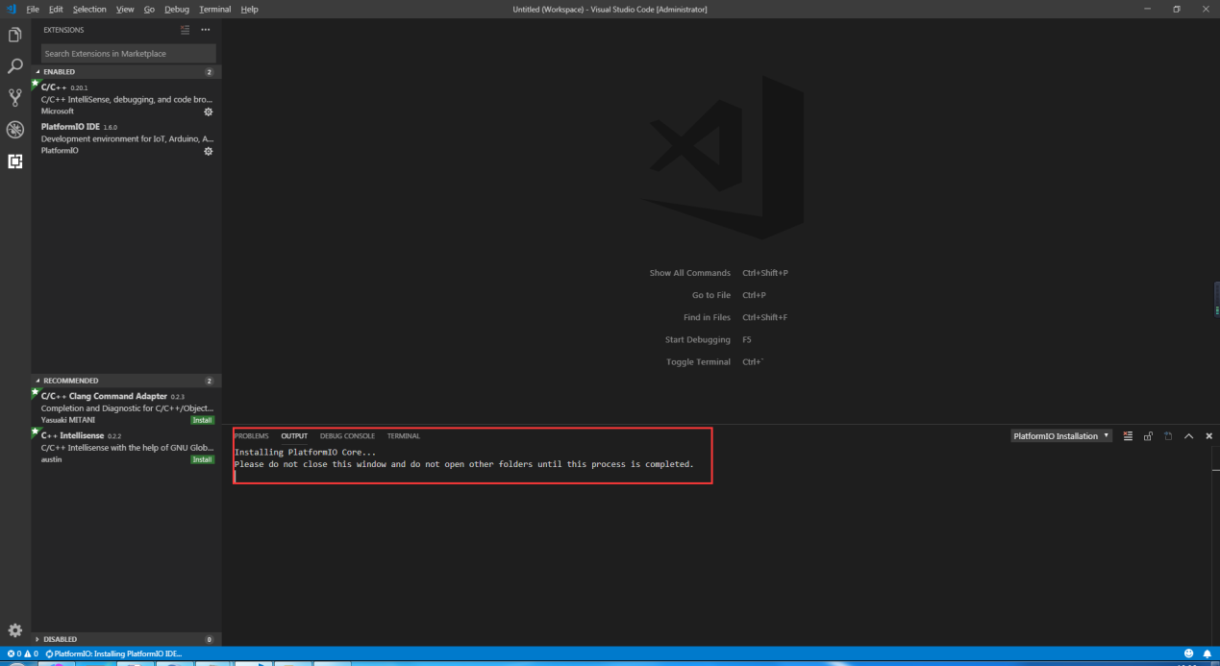

After the installation is successful, you need to Reload and then PlatformIO is installed.

4.In the lower left corner of VSCode, you can see the icon (1), which is PlatformIO plug-in. Click (2) Open Project to Open the Project.

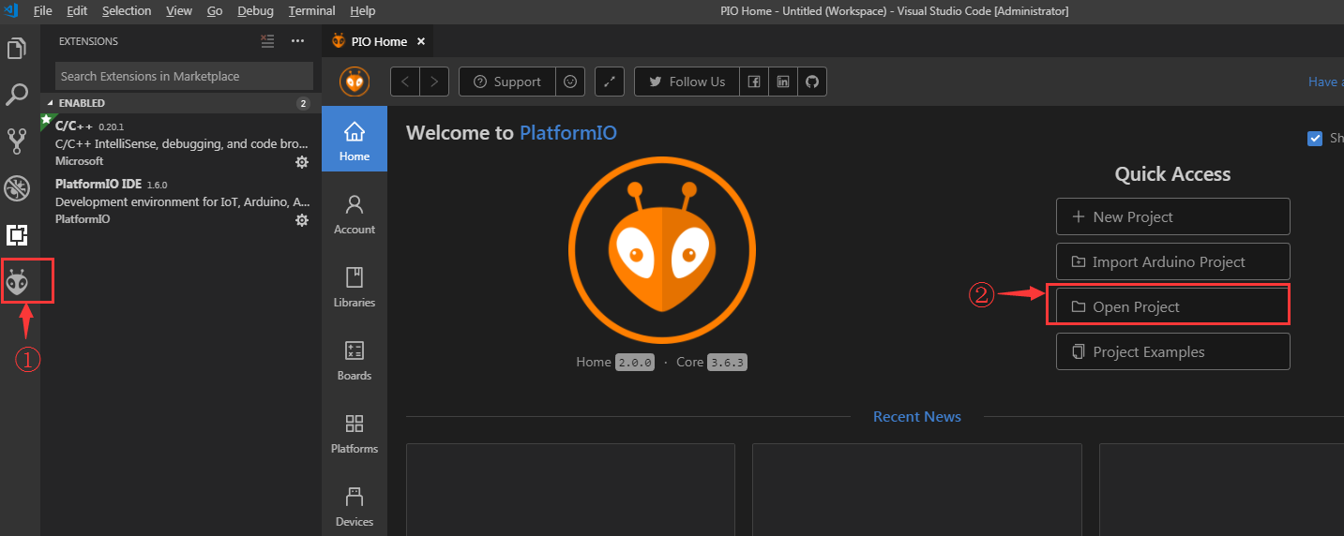

Find the marlin2.0 source directory we extracted In the very first step, and click Open.

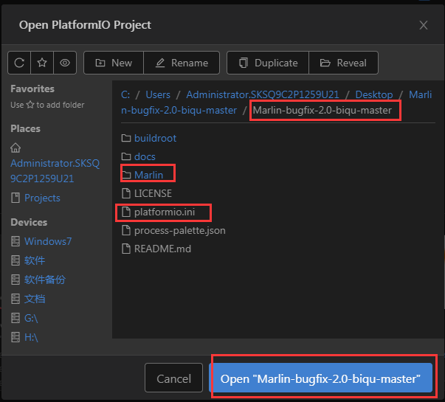

After opening the project, go to the platformio.ini file and change the default environment from megaatmega2560 to LPC1768, env_default = LPC1768

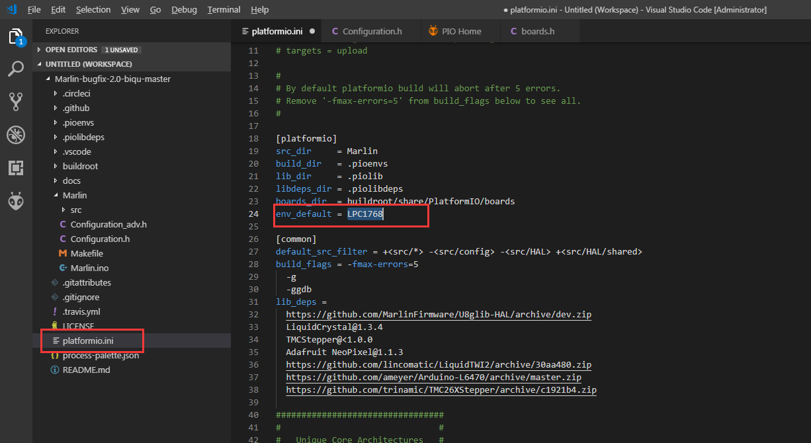

Then go to the configuration.h file and modify it

#define SERIAL_PORT -1

#define SERIAL_PORT_2 0

#define BAUDRATE 115200

#define MOTHERBOARD BOARD_BIQU_SKR_V1_1

Other changes to the configuration.h file may be needed depending on printer setup.

See https://github.com/kckndrgn/Marlin_2.0_SKR_v1.1

This repository has working configuration.h & configurationAdv.h files for my setup which is a converted Anet A8 printer

* Bowden extruder/hotend
* 220x220x240 build area
* 30amp power supply
* 20x20 aluminum frame
* Using stepper motors from the A8

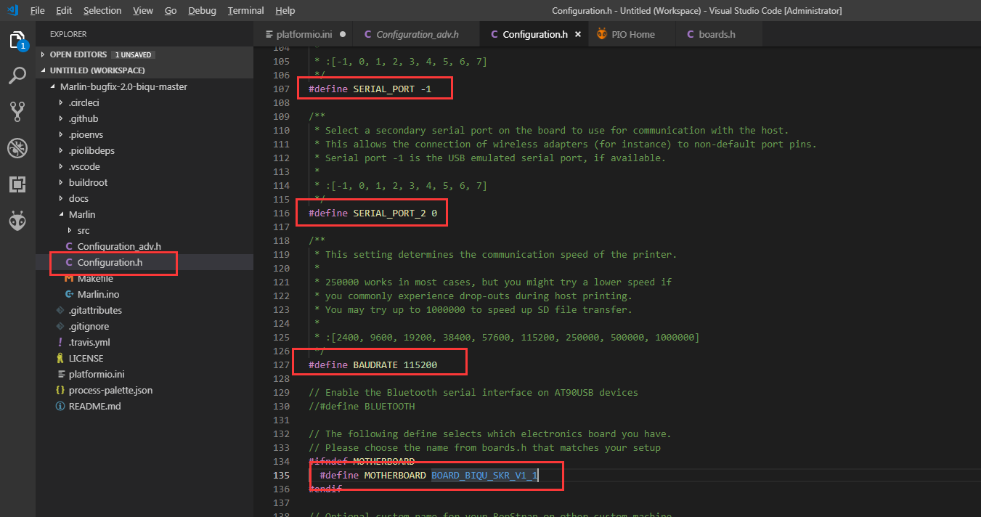

After the modification is completed, press Ctrl+Alt+B, platformio will automatically download the compile component and then compile.

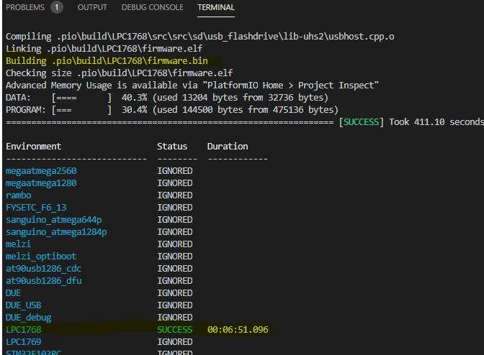

After the compilation is successful, a firmware.bin file will be generated in the .pio\build\LPC1768 directory. We will copy this file to the TF card of the motherboard, and then reset the motherboard, so that the firmware is burned into the motherboard.